FIȘA DE IDENTIFICARE RESURSE EDUCAȚIONALE DESCHISE

DATE DE IDENTIFICARE PERSONALĂ:
Numele și prenumele autorului :ZAHARIA-STREMŢAN LIDIA
Unitatea de învățământ : Şcoala Gimnazială ,,Sf. Gheorghe’’, Sîngeorgiu de Mureş
Disciplina de încadrare : LIMBA ENGLEZĂ

INFORMAȚII PRIVIND MATERIALUL RED:
Denumirea resursei educaționale: Proiect didactic – Lunchtime, manual Fairyland 3, Express Publishing Book

Tema/Scurtă descriere:
Proeiectul didactic are ca scop exersarea şi aprofundarea zilelor săptămânii, cât şi predarea vocabularului pe tema FOOD împreună cu stuctura gramaticală I like/ I don’ t like.

Scopul materialului propus:
- Didactic (de utilizat la clasă)
- Pentru elev (de utilizat pentru elevi)
- De documentare pentru cadrele didactice X
- Altele

Nivel de învățământ/clasă: clasa a 3-a

Aria curriculară/Disciplina

Limbă şi comunicare - LIMBA ENGLEZĂ

Tipul de material didactic:
- Curricular X
- Extracurricular

Competențe vizate:
-exersarea şi aprofundarea noţiunilor de vocabular
-dezvoltarea competenţelor de ascultare şi comunicare

LESSON PLAN

Teacher: Zaharia-Stremțan Lidia
School: Șc. gim. ,,Sf. Gheorghe”, Sângeorgiu de Mureș
Date: 25th April
Grade: 3th A
Level: beginners
Textbook: Fairyland 3
Unit: Food
Lesson : Lunchtime!
Number of students: 32
Aims:
1. to revise Ss’ acquisition concerning the days of the week and a few food words
2. to introduce and practise expressing likes and dislike: Do you like?/I like…/Idon’t like… in statements associated with food and drinks
3. to practise speaking and listening skills
Specific competences:
By the end of the lesson the students will be able:
-to understand and use food vocabulary
-to express and ask about preferences
-to use the grammar structure previously taught, in statements associated with food
Organization: Whole class, Group work, Pair work, Individual work
Teaching methods: singing, miming, story-listening, game playing, matching

Teaching aids: BB, flashcards, posters, handouts, laptop, video projector, a toy caterpillar, paper plates, stickers, flip chart, food samples, ball
Informal conversations (greetings, How are you? Small talk to cheer them up, song “Hello, everybody! “
Activity 1
Warm-up
BALL CONTEST
Aim: to introduce Ss into the right mood for having an English class
Interaction: S-S; S-T
Procedure: Six (numbered) topics the students have already learned about are written on the board (parts of the body, colours, family, animals, food, activities). Ss are given a ball and divided into two teams. Each team is granted 2’ to toss the ball with numbers on it. Wherever their thumb lands when they catch the ball, they call out the number, check what topic it is and say a word that falls into that category. Then they pass the ball to another group mate who does the same. The team that scores the most points is the winner. Each member will receive a sticker reward.
Classroom organization: team work
Timing: 7 minutes
Activity 2
Story reading “The Very Hungry Caterpillar” by Eric Carl
https://www.slideshare.net/samanthamorris211/the-very-hungry-caterpillar-7574597
Aim: to check-up the acquisition of the previous lesson
Interaction: T-S
Procedure: SS are given a matching exercise worksheet containing a few words that Ss will hear in the story. T reads the story of The Very Hungry Caterpillar by Eric Carle and asks students to spell the days of the week on the paper plates that make up the body of the caterpillar.
Classroom organization: pair work, group work
Timing: 10 minutes
Activity 3
Introducing the new lesson
Aim: to enable students to ask and answer questions about preferences: Do you like…? / Yes, I do. / No, I don’t.
Interaction: T-S
Procedure: T draws a smiley face on the board next to a flash card that is generally liked by everybody, for example ice cream and says ‘I like ice cream.’ using body language to emphasize the meaning. T asks students ‘And you? Do you like ice cream?’. T elicits ‘I like ice cream” and drills the sentence. Then T draws a sad face on the board next to a flashcard of the food that is often disliked, for example fish, again doing the same as mentioned above.
Classroom organization: whole class
Timing: 10 minutes

Activity 4
TASTE EXPERTS
Aim: to make SS practise asking and answering questions about likes and dislikes
Interaction: S-S
Procedure: Ss are divided into groups of four and given a bowl with different food samples (apple, orange, broccoli, kiwi, pears, cheese, salami and lemon). With their eyes closed, students taste a food item and says what it is and if they like it or not. Ss are encouraged to say: ‘I love it!/I hate it!’
Classroom organization: group work
Timing: 10 minutes

Activity 5
Feedback
Listening (song listening)
Aim: to consolidate SS practice of food, likes and dislikes
Interaction: T-SS
Procedure: Ss watch and listen to a song. While watching the video and listening to the song, SS are asked tick the food that the alien likes or doesn’t like. Then students sing along.
Classroom organization: individual
Timing: 10 minutes

Homework: 2 minutes
Listen to the song ‘Do you like broccoli ice cream’ (Song by Super Simple Learning) and write down the food that the child likes or doesn’t like.
https://g.co/kgs/cPb2xu

Abbreviations:
S-student
SS-students
T-teacher
BB-blackboard

Bibliography
www. anglomaniacy.pl
Dooley, Jenny and Evans, Virginia –Pupil’s book-Fairyland, Express Publishing Book
Primary IDictionary, Cambridge University Press
https://g.co/kgs/cPb2xu
https://www.slideshare.net/samanthamorris211/the-very-hungry-caterpillar-7574597

This is a picture that shows a group-work activity. SS are writing the days of the week on the paper plates.

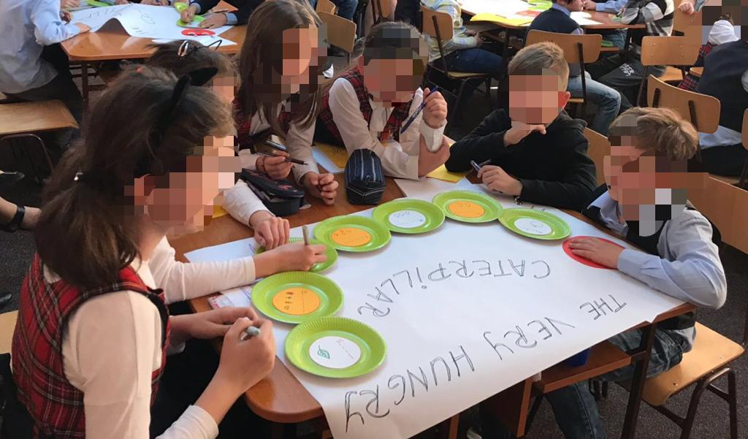

Activity 2 (Worksheet)
THE VERY HUNGRY CATERPILLAR (by Eric Carle)
Match the words to the pictures:

CATERPILLAR 

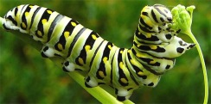
MOON
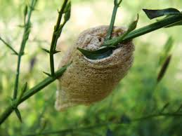

LEAF

COCOON

Activity 5 (Worksheet)

Listen and tick the correct box:


- a glass of water

- a bottle of milk

- a cup of tea

- some paint

- a carton of juice

- a can of cola

- a bowl of soup

- some oil

- some salad

- vegetables and meat

- some pasta

- the phone

Activity 5
The Food and drink song
(Lyrics)

Woman: A glass of water?
Alien: I don’t like water.
Woman: A bottle of milk?
Alien: I don’t like milk.
Woman: A cup of tea?
Alien: I don’t like tea. I’d like to drink some paint.
Woman: A carton of juice?
Alien: I don’t like juice.
Woman: A can of cola?
Alien: I don’t like cola.
Woman: A bowl of soup?
Alien: I don’t like soup. I’d like to drink some oil.
Woman: What about salad?
Alien: I don’t like salad.
Woman: Vegetables and meat?
Alien: I don’t like meat.
Woman: Maybe some pasta?
Alien: I don’t like pasta. I’d like to eat your phone.

ANSWERS
Activity 5 (Worksheet)
Listen and tick the correct box:

- a glass of water

- a bottle of milk

- a cup of tea

- some paint
- a carton of juice

- a can of cola

- a bowl of soup

- some oil
- some salad

- vegetables and meat

- some pasta

- the phone

